

Advanced Point of Sale

Point of Sale system (POS)

**MySQL** Database server configuration guide

September 6, 2018

DynamicSoft

http://www.codecanyon.net/user/dynamicsoft

**How to setup MySQL Database script into MySQL Server/phpmyadmin**

Requirement _____________________________________________________________

* **Visual studio 2010 – up-to** target Framework="4.0"
* **MySQL server – up-to** Server version: 5.6.21
* **MySQL- connector**

**How to setup APOS using MySQL DB – Check this Official video**   
<https://www.youtube.com/watch?v=g91NRvQBRms&t=1673s>

**Before start setup please**

**Install** [**mysql-connector-net**](https://dev.mysql.com/get/Downloads/Connector-Net/mysql-connector-net-6.10.8.msi)  **(If Not installed)**

**Step**: 1

How to Setup Database __ > [**Youtube**](https://www.youtube.com/watch?v=jW5lrS6EUPM) , [**YTD2**](https://www.youtube.com/watch?v=x-R7VnUSXyc)

1. Open Your MySQL server with Xampp [phpmyadmin](http://localhost/phpmyadmin) or workbench tools. http://localhost/phpmyadmin
2. Create a New Database in your mysql DB Name is = “**aposmysqldb**”

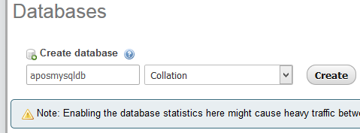

Select Database 🡪 **aposmysqldb** and click Import tab  
Follow on youtube How to DB import 🡪 <https://www.youtube.com/watch?v=jW5lrS6EUPM>

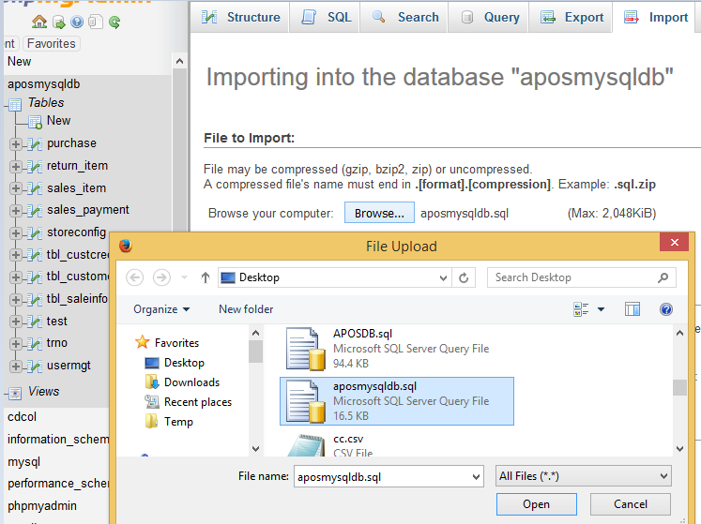

And Upload **aposmysqldb.sql** fileand press **Go**

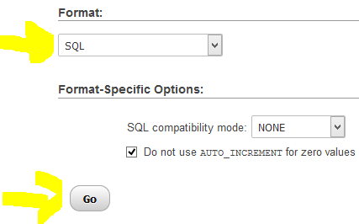

Now see your all tables and views **aposmysqldb.** Done

2. **Install** [**mysql-connector-net**](https://dev.mysql.com/get/Downloads/Connector-Net/mysql-connector-net-6.10.8.msi)  **(If Not installed)**

3. [Open the project](https://www.youtube.com/watch?v=AcOoGkG0m8I) from ***POS_SQLite*** folder with VS 2010. Just click on 🡪 ***Adv_POS.sln*** file

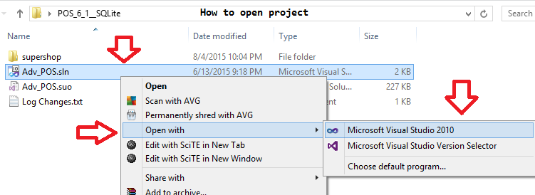

🡪 Delete Current DataAccess.cs file from solution explorer 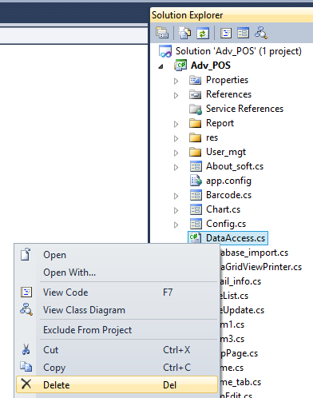

1. And Copy " **DataAccess_MySql.cs** " file from [POS_MySql] folder then paste into solution explorer -> **Adv_POS** project  
   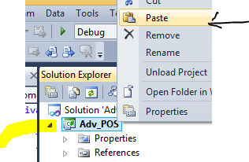
2. Rename it to "**DataAccess.cs**"

Open "DataAccess.cs” file and change your DB source, Database name, User ID, Password.  
In line 16

//This is MySQL Database Access

static string _ConnectionString = "server=localhost; database=aposmysqldb; uid=root; PASSWORD=";

   // server = your server name like IP address or domain name  
//database = your database name   
//uid = MySQL user id  
 // Password = MySQL or cpanel database user ID (default is empty)

3. Install **ReportViewer.exe** from **🡪** 1. Support_files folder and **Install** Font [**UPC-A.ttf**](../../1.%20Support_files/Font-%20Barcode/UPC-A.ttf)from **🡪** Font- Barcode folder (One time if installed plz avoid it)

4. Build and Run or press F5

How to switch **MySQL server** to --> SQLite **server**

1. Delete Current **DataAccess.cs** file from solution explorer
2. and Copy "**DataAccess_SQLiteEdition.cs**" file then paste into solution explorer **Adv_POS** project
3. Install **ReportViewer.exe** from **🡪** 1. Support_files folder (One time if installed plz avoid it)
4. Install Font **UPC-A.ttf** from **🡪** Font- Barcode folder (One time if installed plz avoid it)
5. Build and Run

Optional Setup  
**How to Automatically Open Your Cash Drawer**

<https://www.youtube.com/watch?v=ECid5KGzuzw>

**Pole device or Customer Display Configuration**

Step1: Open SalesRegister/SalesRegister.cs file with Visual studio 2010

// Add below code after line 558 or UnComment Existing code -- find in vatcal() method line 535 ///////Pole shows Price value | if you have pole device please UnComment below code

SerialPort sp = new SerialPort();  
 sp.PortName = "COM1"; ////Insert your pole Device Port Name E.g. COM4 -- you can find from pole device manual   
 sp.BaudRate = 9600; // Pole Bound Rate  
 sp.Parity = Parity.None;  
 sp.DataBits = 8; // Data Bits  
 sp.StopBits = StopBits.One;  
 sp.Open();   
 sp.WriteLine(lblTotalPayable.Text);  
 sp.Close();  
 sp.Dispose();  
 sp = null;

**How to make installer from source code**

Step 1: Please create a new project. (Do not create installer file/project in same project.)

Our Official Video tutorial

<https://www.youtube.com/watch?v=4ca8HPnY8hE>

**User manual – Developers Edition**  
<https://www.youtube.com/watch?v=g91NRvQBRms>

Please don’t forget to Rate us <http://codecanyon.net/downloads>



[DynamicSoft](http://www.codecanyon.net/user/dynamicsoft)